Changing populations

Look at this graph. It has two vertical axes, one for the rabbits and one for the foxes. It shows how the populations of foxes and rabbits have changed in one area. Each population was measured at the middle of every year.

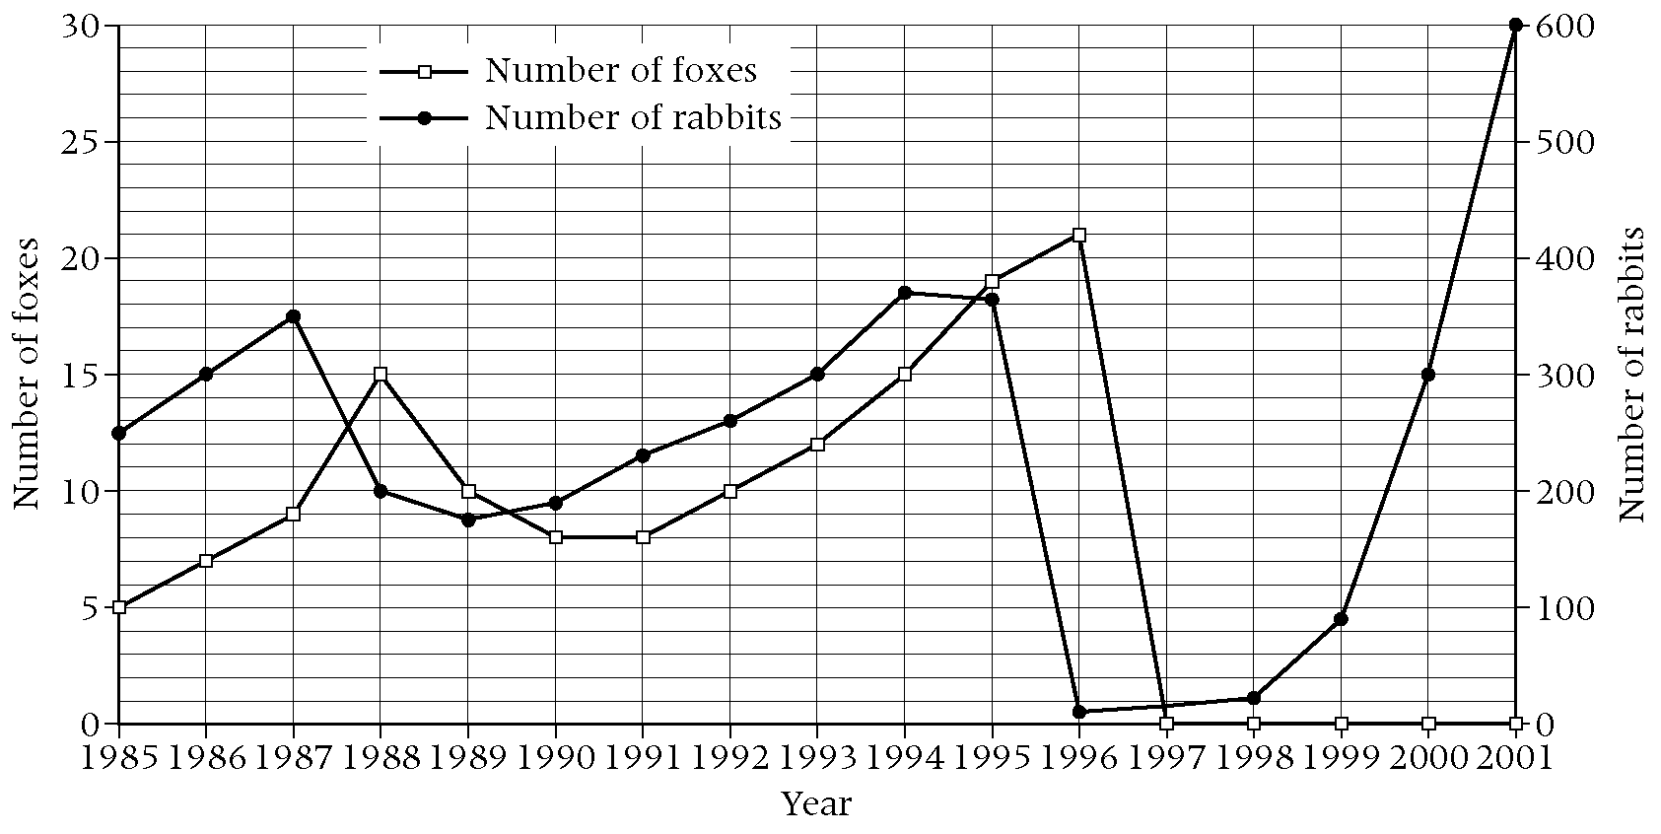

a Which animal is a predator?

b Which animal is preyed upon?

c How many rabbits were there in 1989?

d How many foxes were there in 1993?

e In which year were there the most foxes?

f Explain why the number of foxes fell between 1988 and 1990.

g During 1996 the rabbit population was almost totally wiped out. Give one possible reason for this.

h In 1997 there were no foxes. Give one reason for this.

